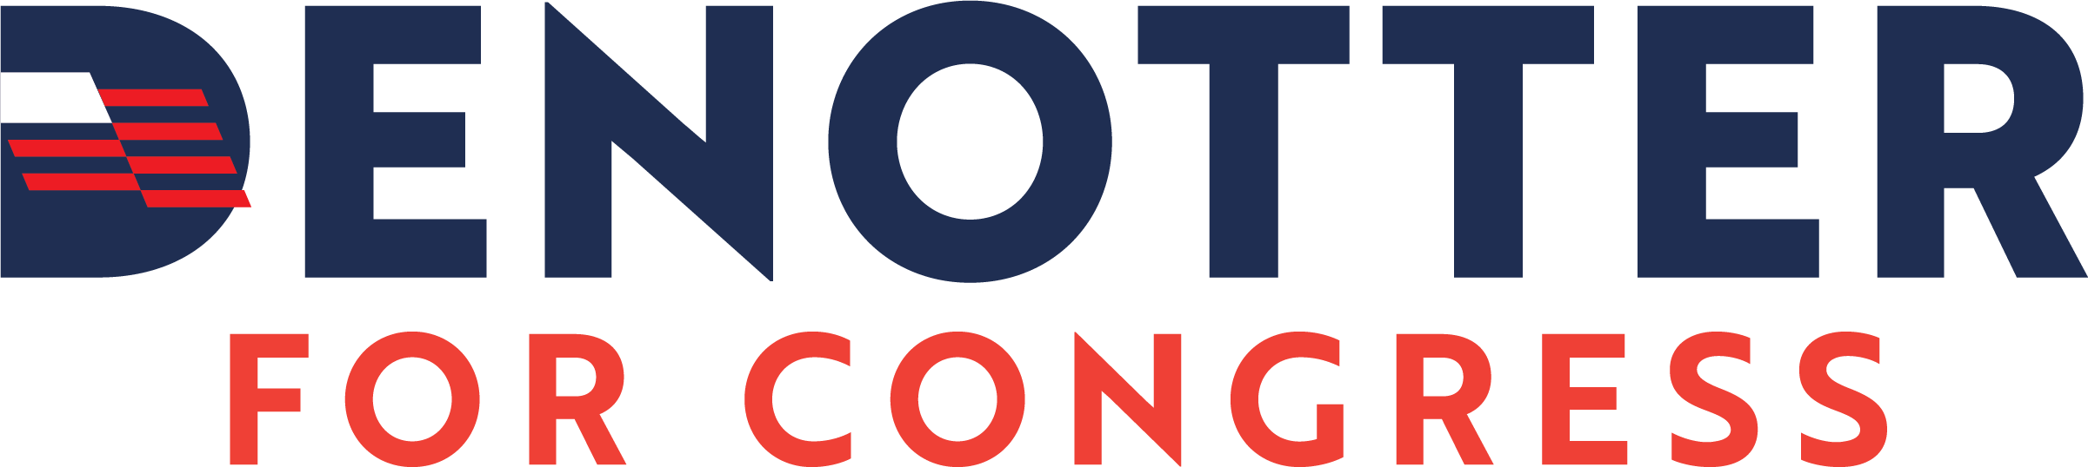

Terms and Conditions
DenOtter for Congress

You agree to receive recurring automated informational and donation text (e.g., SMS and MMS) messages from DenOtter for Congress, including text messages that may be sent using an automatic telephone dialing system, to the mobile telephone number you provided when signing up or any other number that you designate. All the different types of messages you may receive (Informational messages, vote reminders, and donation messages) shall be known collectively as the "Programs." Consent to receive automated informational and donation text messages is not a condition of any purchase.

Cost

Msg & Data rates may apply. Please consult with your carrier for rate information.

Message Frequency

Message frequency will vary. DenOtter for Congress reserves the right to alter the frequency of messages sent at any time, to increase or decrease the total number of sent messages. DenOtter for Congress also reserves the right to change the phone number from which messages are sent. Not all mobile devices or handsets may be supported, and our messages may not be deliverable in all areas. DenOtter for Congress, its service providers and the mobile carriers supported by the programs are not liable for delayed or undelivered messages.

Cancellation

If you do not wish to continue participating in any Program or no longer agree to these Terms, you agree to text the applicable Short Code (or regular long code phone number where applicable) or directly reply to any mobile message received from a Program with STOP, END, CANCEL, UNSUBSCRIBE, or QUIT in order to opt out of that Program at any time. You may receive an additional mobile message confirming your decision to opt out. You understand and agree that the foregoing options are the only reasonable and exclusive methods of opting out. You also understand and agree that any other method of opting out, including, but not limited to, texting words or phrases other than those set forth above or verbally requesting DenOtter for Congress to remove you from our list, is not a reasonable means of opting out. You may be subscribed to multiple Programs across different Short Codes or regular long code phone numbers, and therefore you must separately text or reply STOP to each Short Code or long code phone number from which you wish to unsubscribe.

Collected Personal Information

Your data will not be sold and will not be used for lead generation or affiliate marketing

Support

For support regarding the Program, text “HELP” to the applicable Program’s Short Code or long code or email us at contact@denotterforcongress.com. Please note that the use of this email address, or texting “HELP” to the Program’s Short or long Code is not an acceptable method of opting out of the program. Opt outs must be submitted in accordance with the procedures set forth above.

Our Disclaimer of Warranty
The Programs are offered on an "as-is" basis and may not always be available in all areas and may not continue to work in the event of product, software, coverage or other changes made by your wireless carrier. We will not be liable for any delays or failures in the receipt of any mobile messages connected with any Program. Delivery of mobile messages is subject to effective transmission from your wireless service provider/network operator and is outside of our control. We are not liable for delayed or undelivered mobile messages.

Privacy Policy

We respect your privacy. We will only use information you provide to transmit your mobile messages and respond to you, if necessary. This includes sharing information with our program partners, message content providers, phone companies, and vendors who assist us in the delivery of mobile messages. EXCEPT AS SET FORTH IN THIS SECTION, WE DO NOT SELL, RENT, LOAN, TRADE, LEASE OR OTHERWISE TRANSFER FOR PROFIT ANY PHONE NUMBERS OR CUSTOMER INFORMATION COLLECTED THROUGH PROGRAMS TO ANY THIRD PARTY. Nonetheless, we always reserve the right to disclose any information as necessary to satisfy any law, regulation or governmental request, to avoid liability, or to protect our rights or property. When you complete forms online or otherwise provide us information in connection with a Program, you agree to provide accurate, complete, and true information. You agree not to use a false or misleading name or a name that you are not authorized to use. If in our sole discretion, we believe that any such information is untrue, inaccurate, or incomplete, or you have opted into a Program for an ulterior purpose, we may refuse you access to the Program and pursue any appropriate legal remedies. This Privacy Policy and Terms and Conditions is strictly limited to these Programs and has no effect on any other privacy policy(ies) that may govern the relationship between you and us in other contexts.



